Yolov8 Model
The project has been started by main dataset in Kaggle.
Driving Video with Object Tracking
The dataset has 1000 videos, with mot_labels.csv
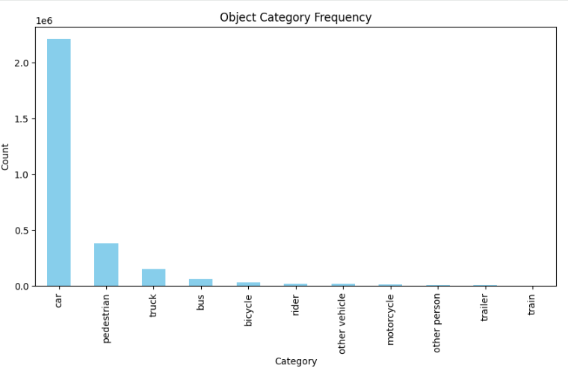
The category distribution plot reveals a strong class imbalance in the dataset, with cars representing the overwhelming majority of annotated objects, while other categories such as pedestrians, trucks, buses, and bicycles appear far less frequently. This imbalance significantly affects model learning because YOLO performs best when classes are well-represented. To avoid biased training, reduce noise, and maintain consistent annotation quality, I chose to focus only on the car category for detection. This decision ensures that the model is trained on the most abundant and reliable class in the dataset, leading to stronger performance and more stable results.

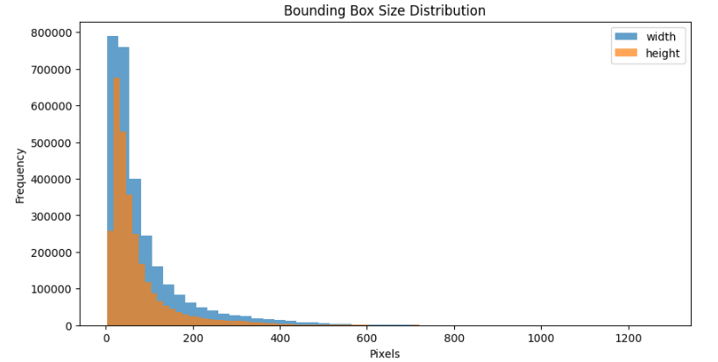
This chart shows how wide and tall the bounding boxes are across the entire dataset. Both width (blue) and height (orange) follow the same pattern: most objects are small, so their boxes fall between about 20 and 150 pixels, and very few objects are large, which is why the bars quickly drop as the size increases. Width values are slightly higher than height values because vehicles in driving videos are usually wider than they are tall. Overall, the plot shows that most detected objects are small and far away, with only a small number appearing large in the frame.
YOLOv8 Dataset Generation
I created an efficient pipeline to turn the driving videos and MOT labels into a YOLOv8 dataset.
First, I set up the YOLO folder structure and loaded the CSV, keeping only the car class. Then I split videos into train and validation sets.
To speed things up, I indexed all video paths once and grouped all labels by video and frame. This avoided repeated searching during processing. If a .mov file couldn’t open, it was automatically converted to .mp4.
For each labeled frame, I read the frame, resized it to 640×640, adjusted the bounding boxes, converted them to YOLO format, and saved both the image and label. Only frames with valid boxes were stored.
Finally, the script summarized how many images and labels were created and automatically generated the dataset.yaml, making the dataset ready for YOLOv8 training.
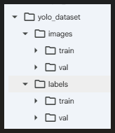
This picture shows the final output of the YOLO dataset-generation pipeline. On the left, the folder structure yolo_dataset is displayed, containing the required YOLOv8 directories: images/train, images/val, labels/train, and labels/val. On the right, the system messages confirm successful dataset creation: a total of 180,202 images and 180,202 label files were saved into the dataset folders, and 468 videos were skipped due to missing or unreadable files. Finally, a dataset.yaml file was automatically generated inside the yolo_dataset directory, which makes the dataset fully ready for YOLOv8 training.
For working with this model and getting good results we used different strategies:
Strategy 1:
At first, the plan was to train on the entire dataset, but the training time became extremely long. Even with a T4 GPU, the Colab disk kept getting full, because many temporary files were written locally even though most data was stored in Google Drive. Adding extra RAM did not solve the disk issue. We also faced frequent Google Drive timeout errors during loading. Because of these problems, the decision was made to train only on a smaller subset of about 70,000 samples.
Strategy 2:
We prepared a subset of 70,000 samples, extracted their images and labels, and trained the model. The training took a long time, but everything ran smoothly until the final plotting step, where an error occurred. Fortunately, the trained model was saved, but the processed 70,000-image dataset itself had not been saved due to a moment of oversight. Still, we were able to continue with the saved model. The results were very poor, and the model could not detect anything. This showed us that starting with a very large dataset from the beginning was not the right approach.

Strategy 3:
As an experiment, the 3,000-sample dataset was trained using the weights learned from the previous 70,000-sample training. The result was not good: the model could only detect about one car out of every five images, even though many cars were present. This showed that this approach was not effective, and the training strategy needed to be changed.
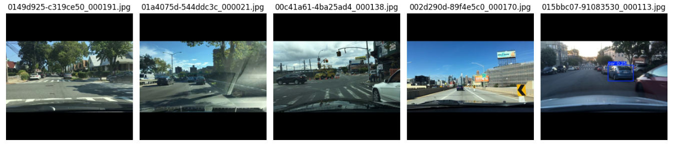
As another idea, the plan was adjusted to increase the dataset to 4,599 samples by selecting only the busiest videos with the highest number of cars, hoping this would improve learning. However, even with these carefully chosen high-car frames, the results still did not improve, and the model continued to perform poorly. This confirmed that this strategy was also ineffective and needed to be changed.
After that, the 4,599 busy-car samples were trained using the original YOLOv8 COCO weights instead of the 70K+3K model. The results were slightly better, because the model was able to detect cars in some moments of the video, but the performance was still inconsistent and far from reliable, showing that this strategy also needed further improvement.
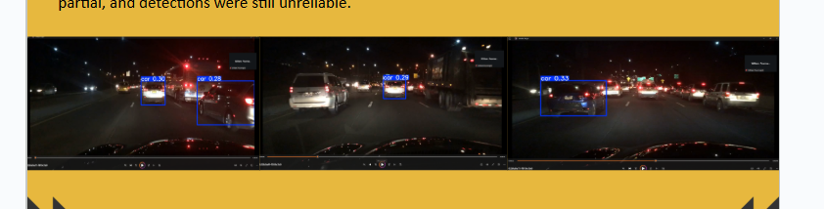
Training the 4,599-sample dataset using the original YOLO weights showed only limited success, as the model could detect cars in a few moments but still missed many others, making the performance unsatisfactory overall.
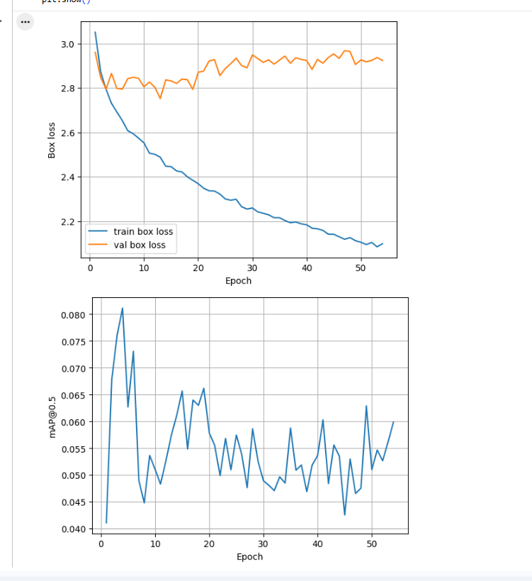
The training and validation loss curves show a clear gap between the two: the training loss keeps decreasing while the validation loss stays almost flat, which means the model is overfitting and not learning to generalize to new data. The mAP@0.5 plot also remains very low and unstable, moving between 0.04 and 0.08, showing that the model cannot consistently detect cars. Together, these graphs confirm that the model’s performance on the 4,599-sample dataset is weak and unreliable.

After increasing the dataset to 10,599 samples and training the model again, the detection performance improved compared to previous attempts, and the model was able to recognize cars more often. However, the overall results were still not satisfactory, especially because the performance plots showed unstable behavior and weak generalization. This confirmed that even with more data, the model was not performing reliably enough.
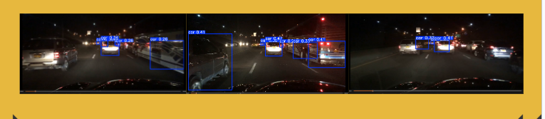
Because the model’s behavior was unexpected, it became important to check whether the CSV annotations were correct. To verify the label quality, the bounding boxes were visualized directly on the raw images before any cleaning or processing. This allowed us to see whether the annotations were accurate or if labeling issues were contributing to the model’s poor performance.

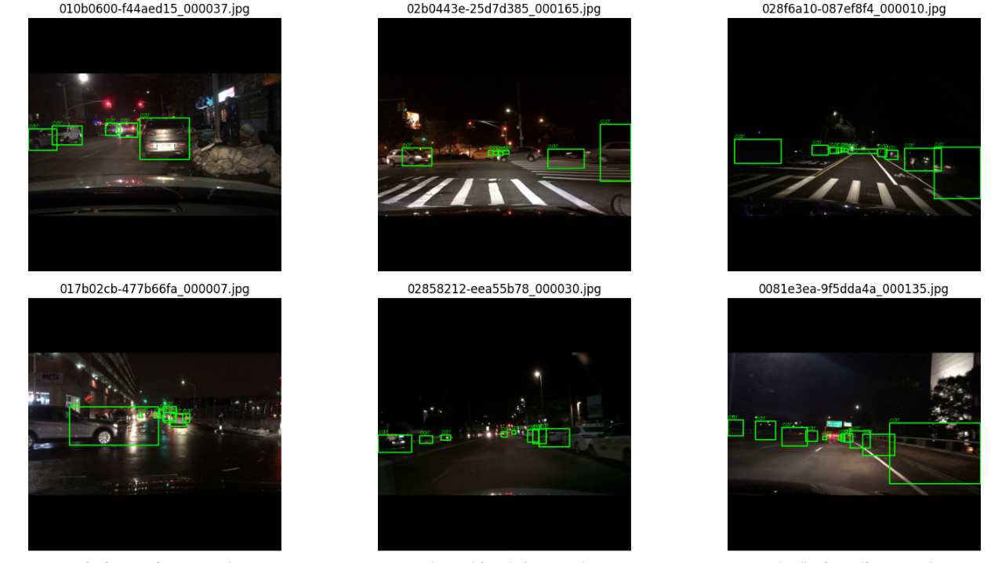

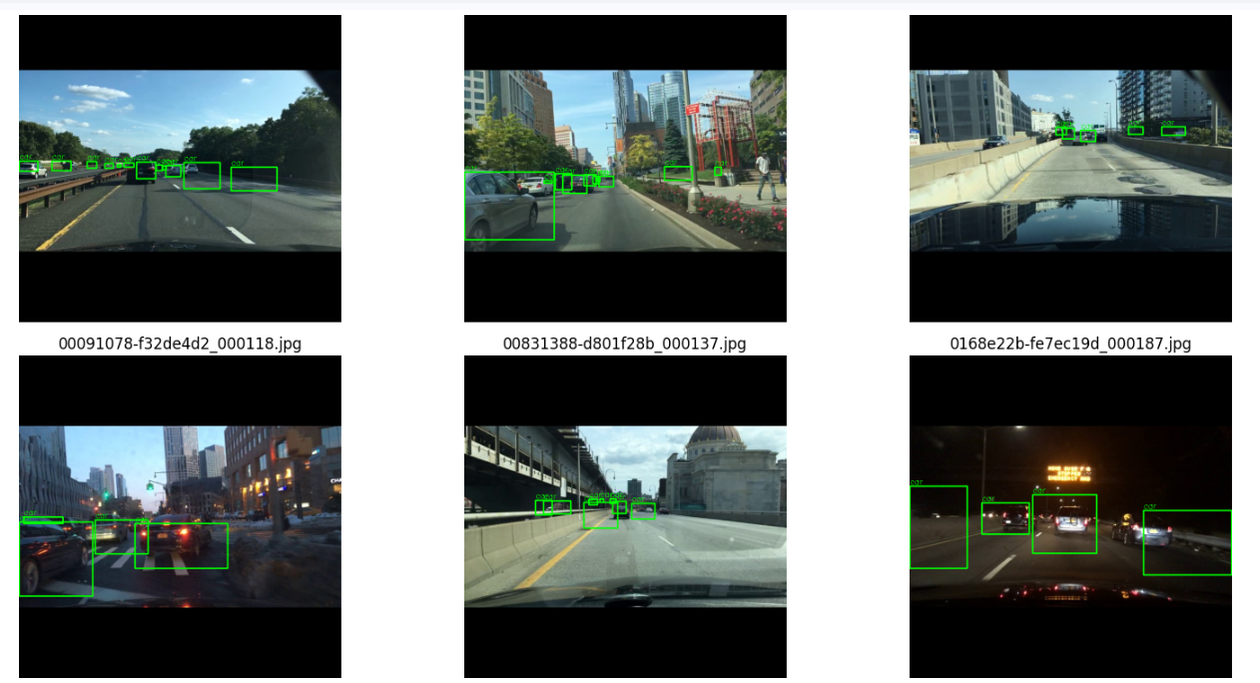
Based on the visual inspection of many sample images, we found that a significant number of bounding boxes in the original CSV annotations were incorrectly placed. This confirmed that the primary reason for the model’s poor performance was the low-quality labels rather than the size of the dataset. Therefore, we created a new, clean dataset by manually labeling the images using the MakeSense.ai (Make Sense ) annotation website.
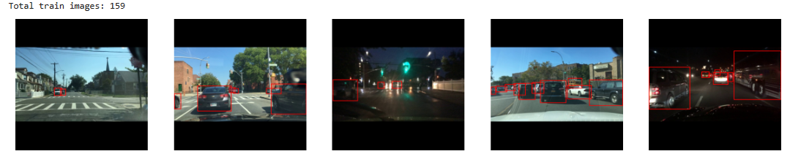
From the 10,000 YOLO-ready images, about 200 random frames (covering roughly 10–12 videos) were selected and manually labeled using the annotation website. This produced around 1,636 high-quality bounding boxes in a clean CSV file, providing a reliable dataset for model training.

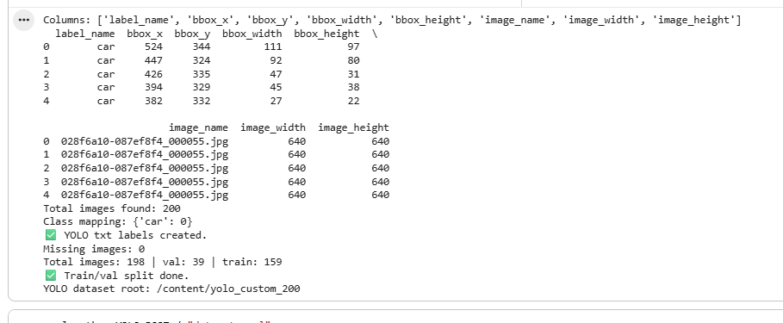
Explanation of the Training Process:
The model was trained using a structured two-stage strategy designed to stabilize learning on a small, manually labeled dataset and then progressively increase model capacity for higher accuracy.
In Stage 1, the backbone was frozen to avoid disrupting the pretrained weights, and the training focused on adapting the model’s detection head to the new dataset. A relatively strong augmentation pipeline was applied, including HSV jitter, rotations, translations, scaling, mosaic, mixup, and copy-paste to compensate for the limited dataset size and improve generalization.
A warm-up learning rate schedule with the AdamW optimizer, cosine decay, and a small number of warm-up epochs helped prevent divergence. After 40 epochs, the model converged with stable losses and produced a reliable set of intermediate weights (“best.pt”).
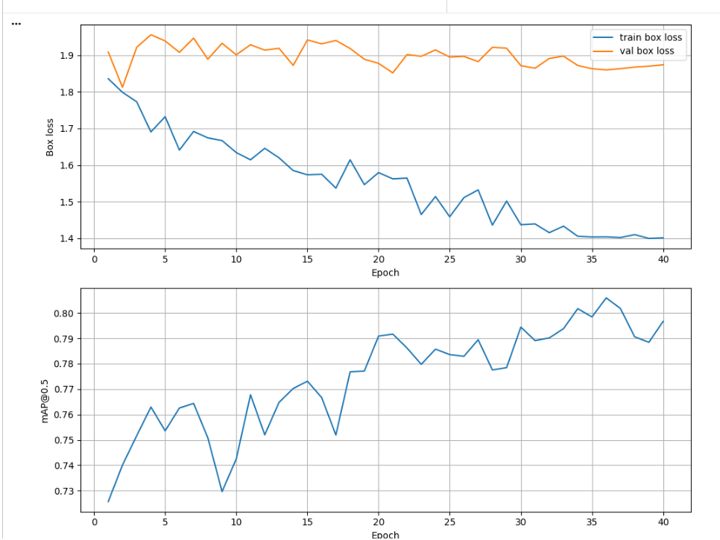
During Stage 1, where the backbone was frozen and strong augmentation was applied, the model showed consistent improvement in localization performance. The training box loss decreased steadily from approximately 1.8 to 1.4, confirming that the detection head was adapting to the manually labeled dataset. As expected in a frozen-backbone warm-up phase, the validation box loss remained relatively high due to aggressive augmentation and limited feature updates. Despite this, mAP@0.5 gradually increased and stabilized around 0.80 by the end of 40 epochs, providing a solid foundation for fine-tuning in Stage 2.
In Stage 2, the best weights from Stage 1 were loaded, the entire network was unfrozen, and the model was fine-tuned end-to-end using a smaller learning rate to prevent catastrophic forgetting. Augmentation remained active but was slightly reduced, and mosaic augmentation was gradually disabled during the final epochs to make training more realistic.
The optimizer and LR schedule were adjusted to support fine-tuning, and all layers were allowed to update. After 80 additional epochs, the model again converged, producing improved validation metrics.
Finally, the best checkpoint from Stage 2 was evaluated on the validation dataset, generating mAP@0.5 and mAP@0.5:0.95, along with confusion matrices, PR curves, and detection samples. This two-stage approach ensured stable warm-up learning followed by full-model refinement, resulting in significantly better performance compared to using a single training stage.
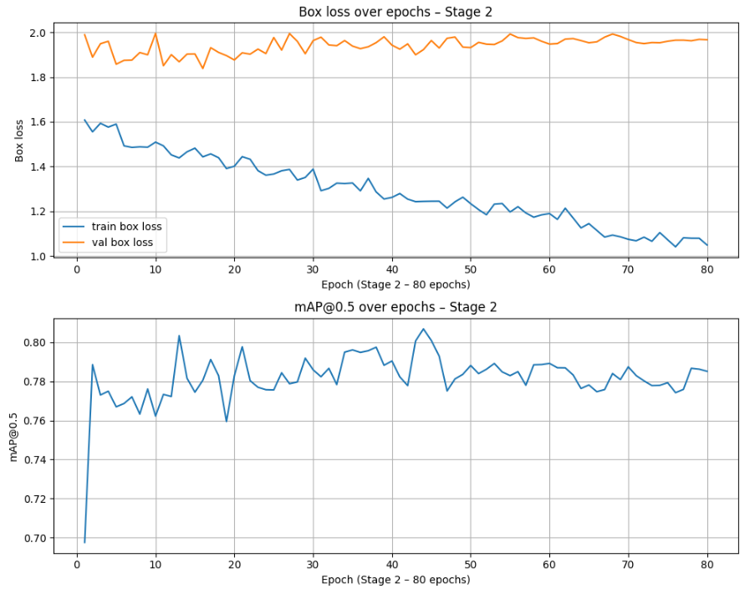
In Stage 2, the backbone was unfrozen and the model was fine-tuned end-to-end using a smaller learning rate and slightly reduced augmentation strength. As shown in the training curves, the train box loss continued to decrease steadily from approximately 1.55 down to about 1.10 over 80 epochs, indicating that the full network was now effectively learning richer spatial and visual features. The validation box loss remained relatively stable around ~1.90, which is expected for a small dataset with only 39 validation images and reflects the natural variability introduced by aggressive augmentation and the limited size of the validation split. The mAP@0.5 curve shows consistent performance in the range of 0.78–0.81, with several peaks exceeding the best values from Stage 1, confirming that fine-tuning the entire network improved detection capability. Overall, Stage 2 successfully refined the pretrained weights and produced the best-performing checkpoint used for final evaluation.
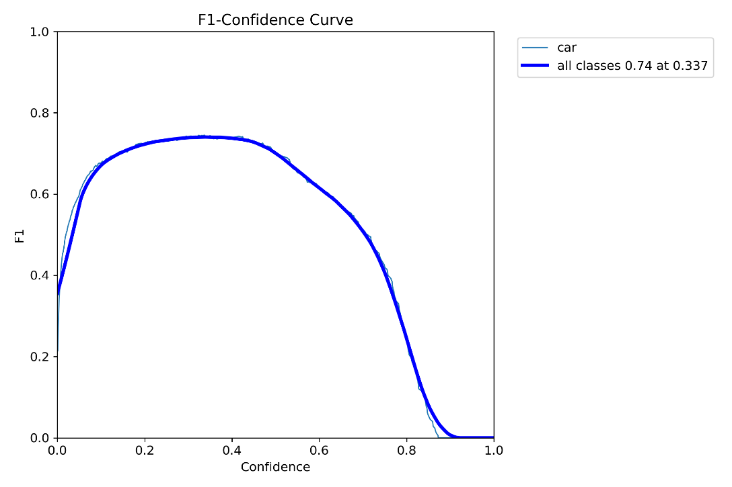
This F1–Confidence curve shows how the model’s F1 score changes as the confidence threshold increases, with the peak F1 of 0.74 occurring at a confidence of 0.337. This indicates that the model performs best when predictions with confidence above roughly 0.34 are kept, and performance drops when the threshold becomes too strict.

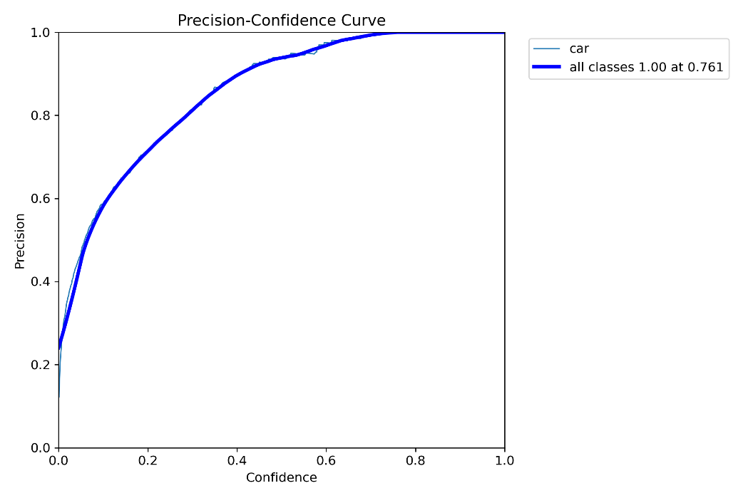
This Precision–Confidence curve shows that precision steadily increases as the confidence threshold becomes higher, reaching its maximum value of 1.00 at a confidence level of 0.761. This means that when the model only keeps predictions above roughly 0.76 confidence, it makes almost no false-positive detections.
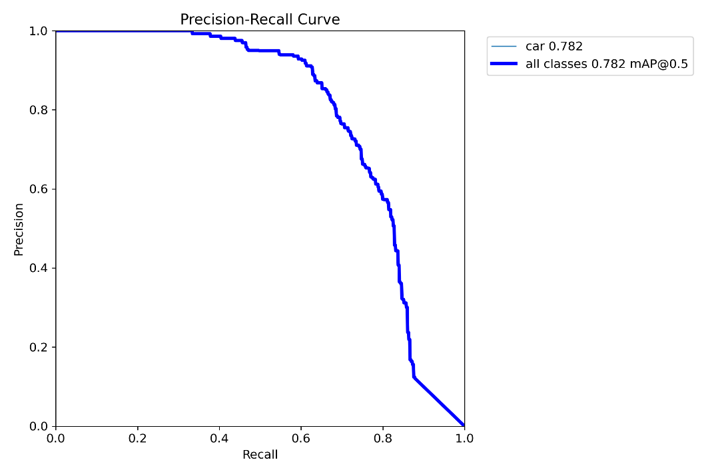
This Precision–Recall curve shows how the model balances correct detections against missed detections, reaching an overall mAP@0.5 of 0.782 for the car class. Precision remains very high at moderate recall levels and only drops sharply when the model attempts to capture nearly all objects, which is typical for small datasets.
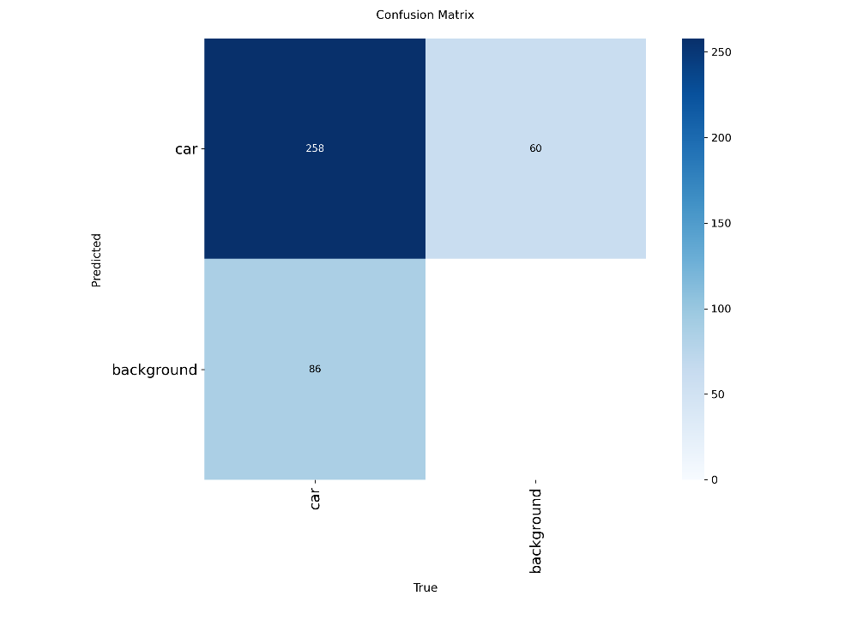
This confusion matrix shows that the model correctly detected 258 cars, while producing 60 false positives (predicting “car” where no car exists) and 86 false negatives (missing cars in the image). Overall, the model identifies most cars correctly but still struggles with some background regions and a small number of missed detections, which is expected given the small dataset size.

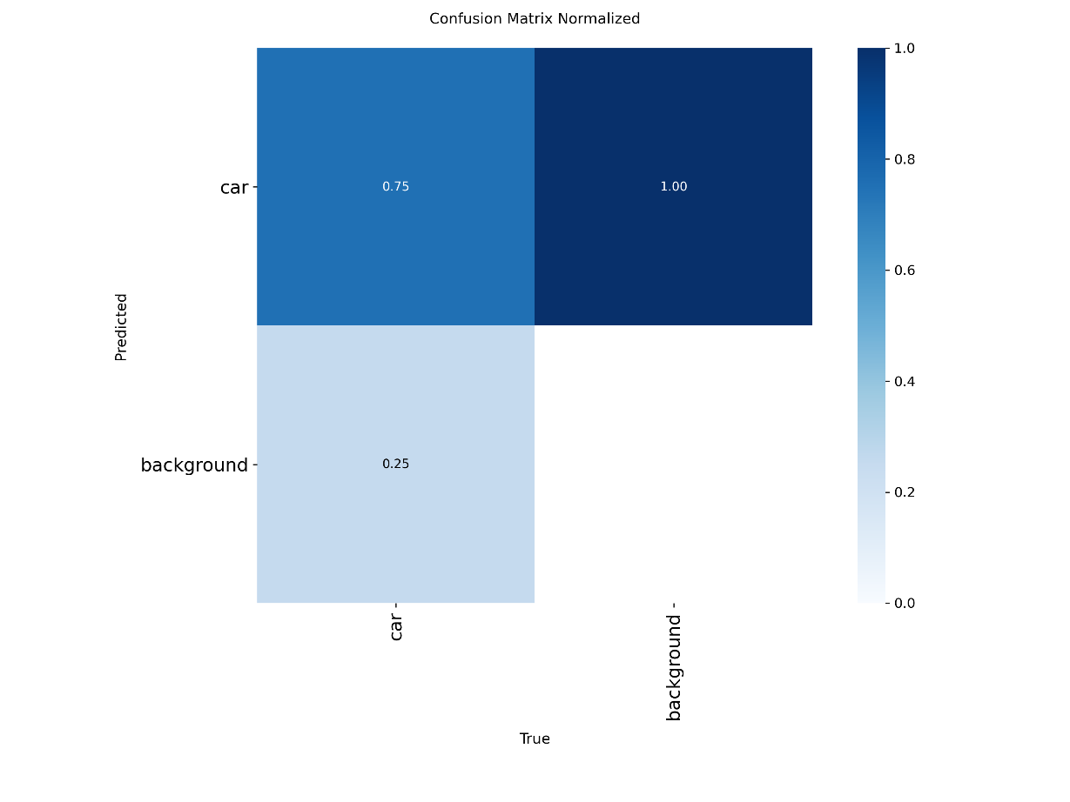
This normalized confusion matrix shows that the model correctly identifies 75% of all car instances, while 25% of true cars are missed and classified as background. The background class reaches a perfect score (1.00), meaning the model almost never misclassifies background regions as cars when normalized by the background class.

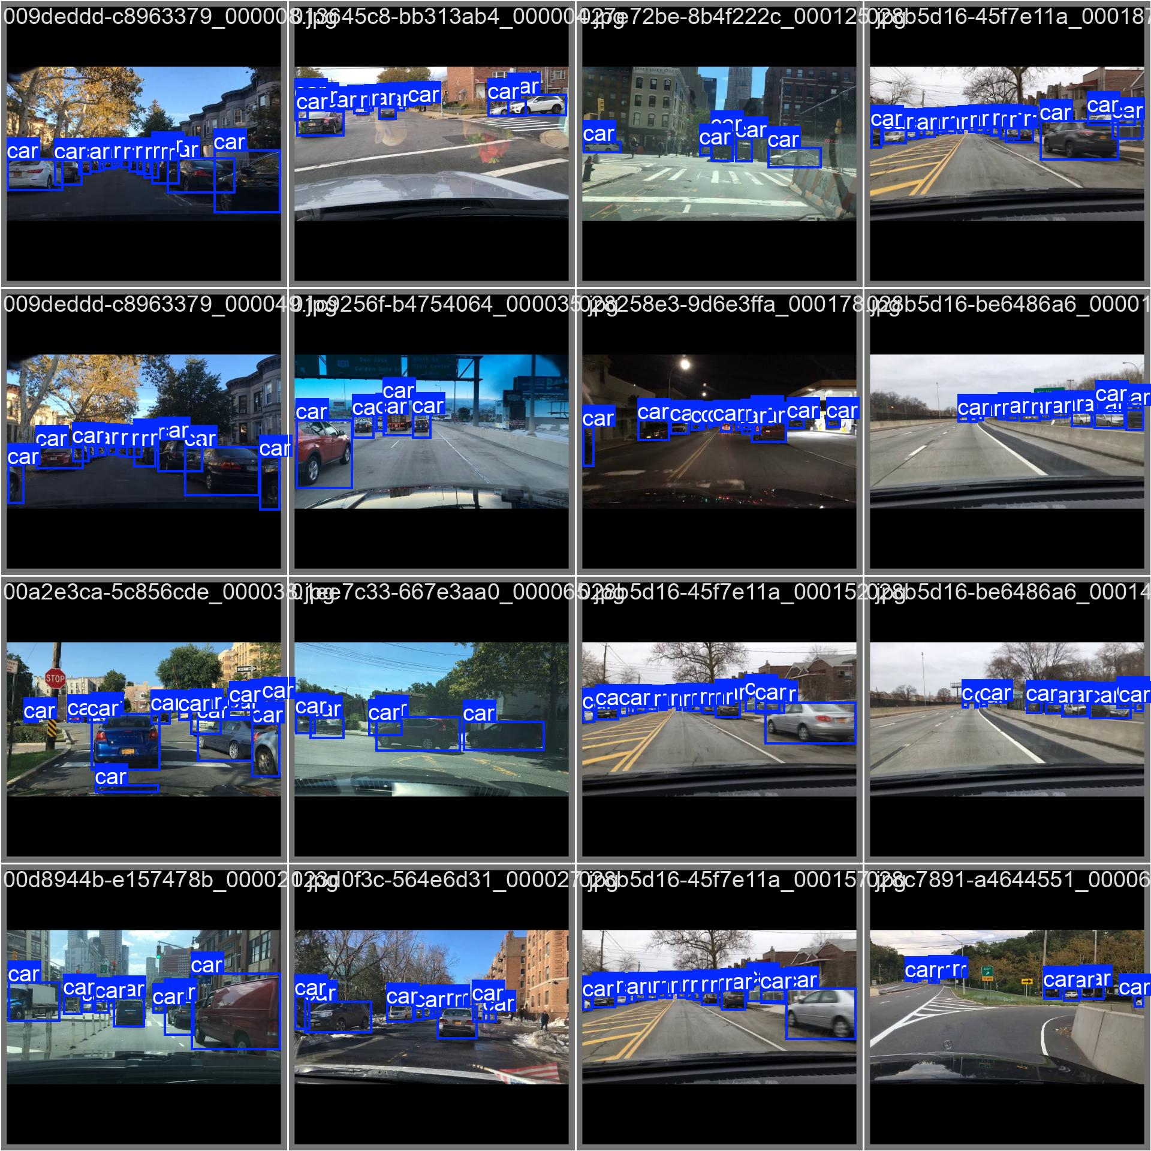
This is the labeled pic before training
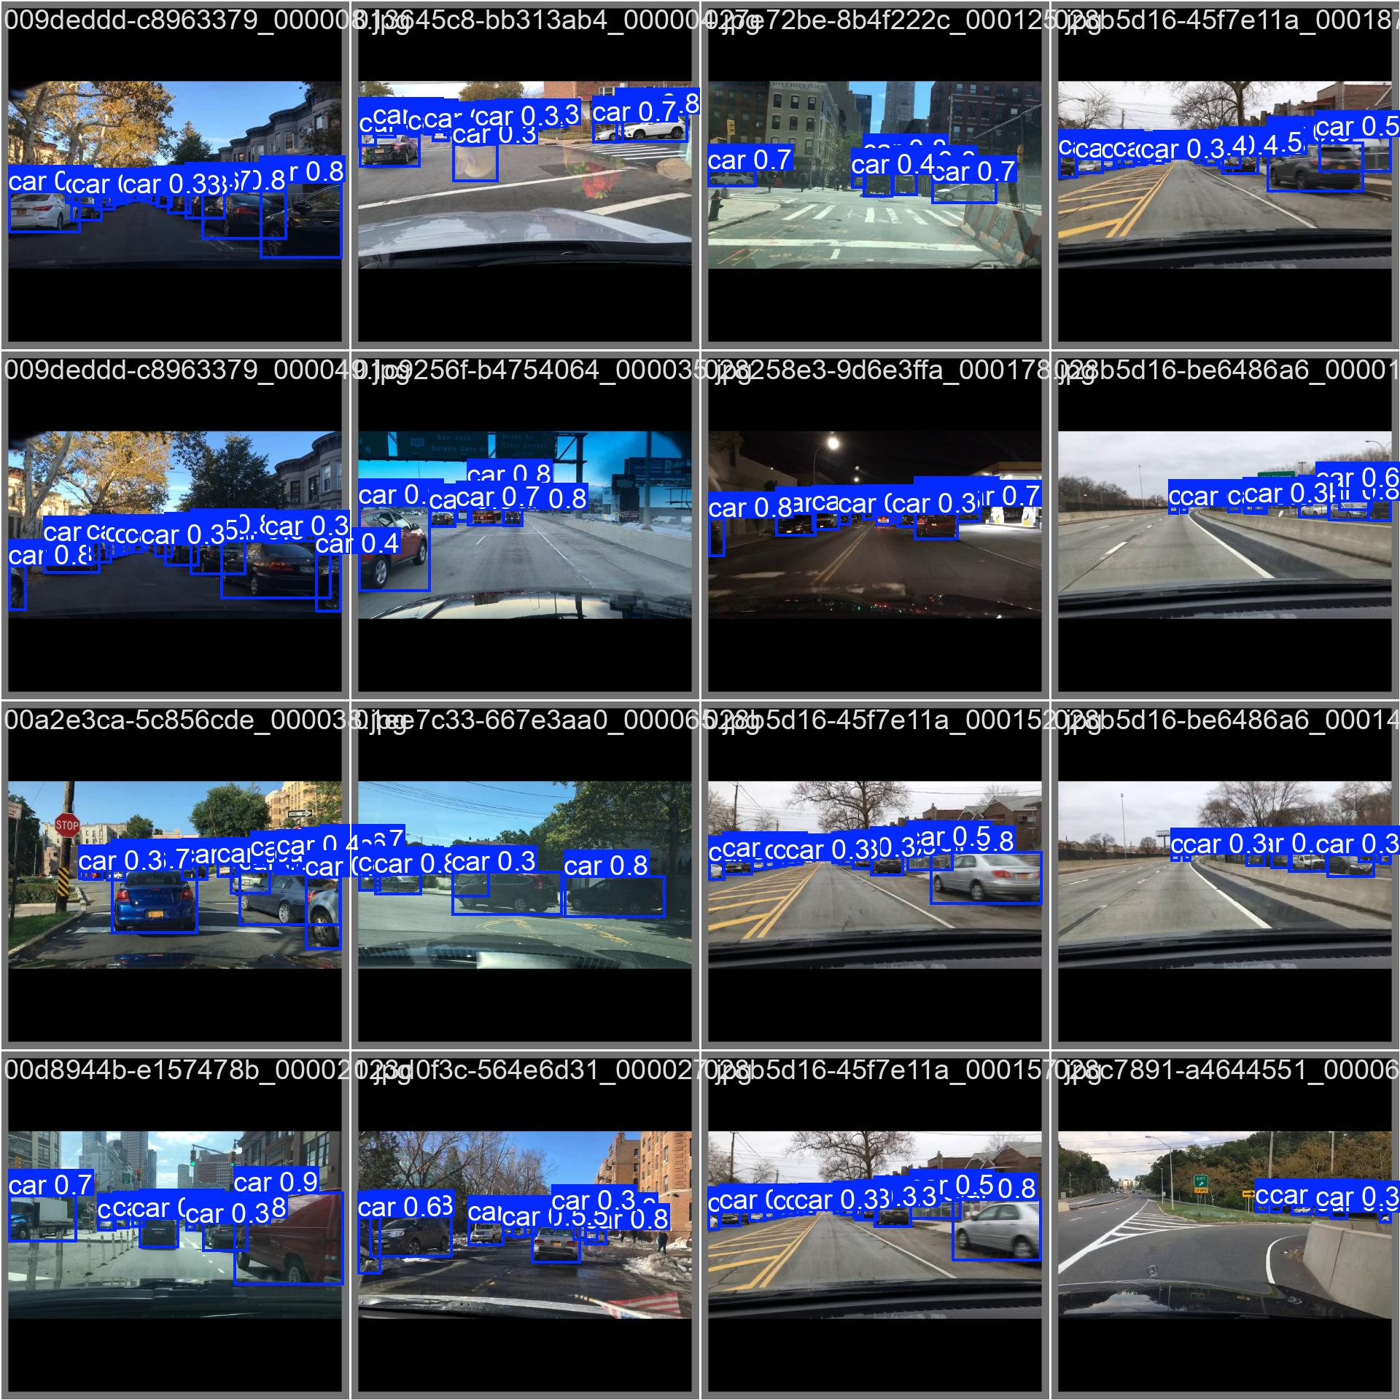
This is the prediction of model after training.
These sample detection images show that the model is able to consistently identify multiple cars across different lighting and road conditions, including daytime, nighttime, and complex urban scenes. The predicted bounding boxes and confidence scores demonstrate stable performance and good generalization, even on crowded frames with many overlapping vehicles.
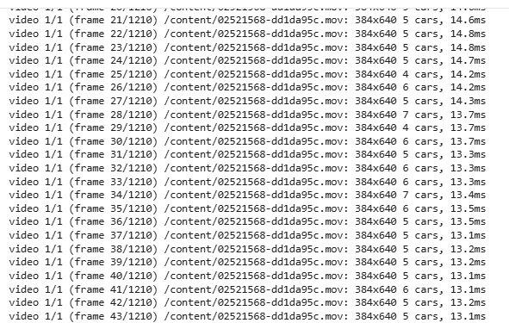
To further validate the model’s performance, I executed inference on sample driving videos. The frame-by-frame predictions were generated correctly and stored in the designated output folder for review.

